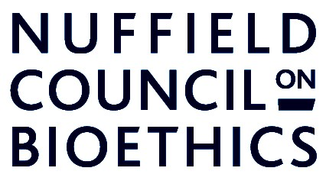

Improving asthma treatments for children and young people

Assent form for children and young people

Please take your time to read the information sheet and ask any questions you have before signing this assent form. Please tick all the boxes.

I have read and understood the information sheet and I have had the opportunity
to ask questions.

I understand that I do not need to take part if I do not want to and that I am free to stop
taking part at any time without giving any reason.

I understand that the study involves changing my asthma treatment and I have discussed
these changes with my doctor and understand the possible side-effects.

I agree that a gene test can be taken (using a cotton swab) to find out my gene-type.

I agree to take part in the online questionnaire and am happy for my responses to be recorded
for the purposes of the study.

I agree to take part in lung function tests and exercise tests and I am happy for my results to
be recorded for the purposed of the study

I have talked to my parents/guardians and doctor about the study.

I agree to take part in the study.

Name of Participant…………………………………………………………………..

Signature………………………….………..Date…………………………………….

Name of Person seeking assent………………………………………………….....

Signature…………………………………..Date……………………………………..

