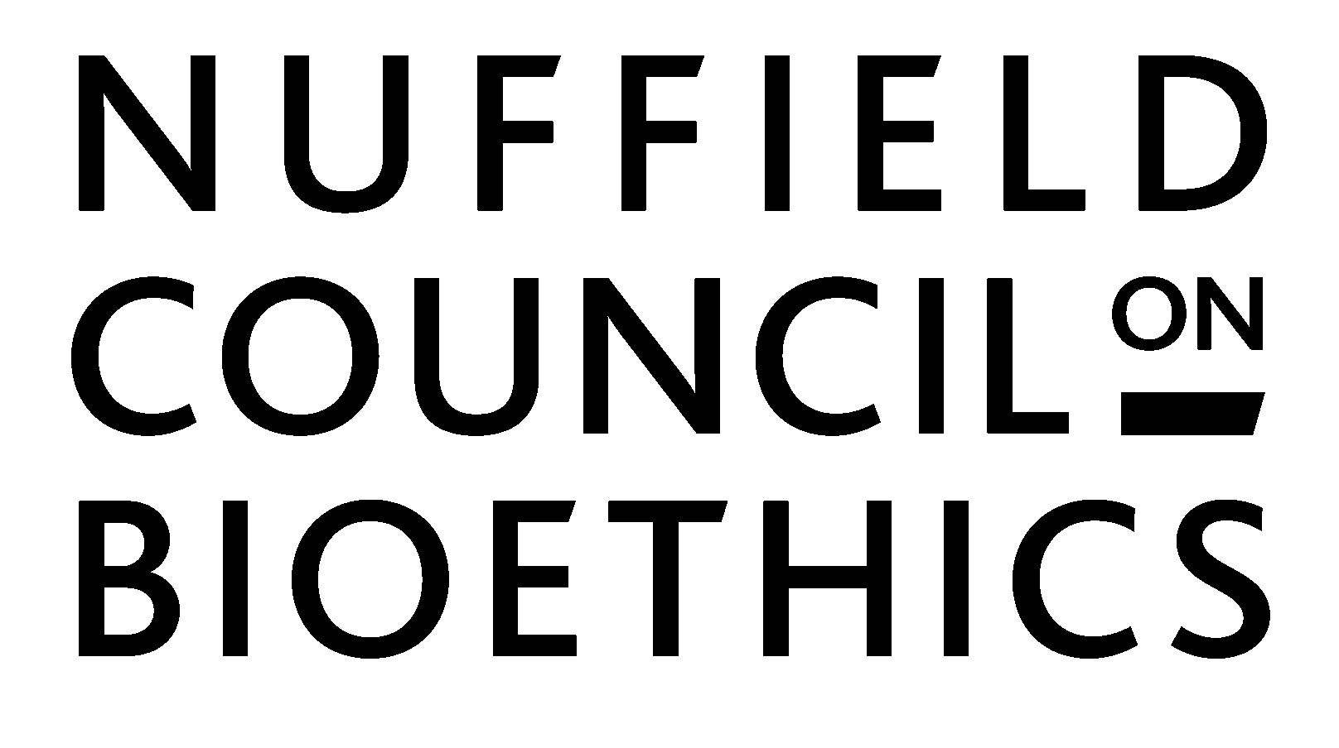

Genome Editing and Farmed Animals

OPEN CALL FOR EVIDENCE

Published 20 June 2019
Closing 20 September 2019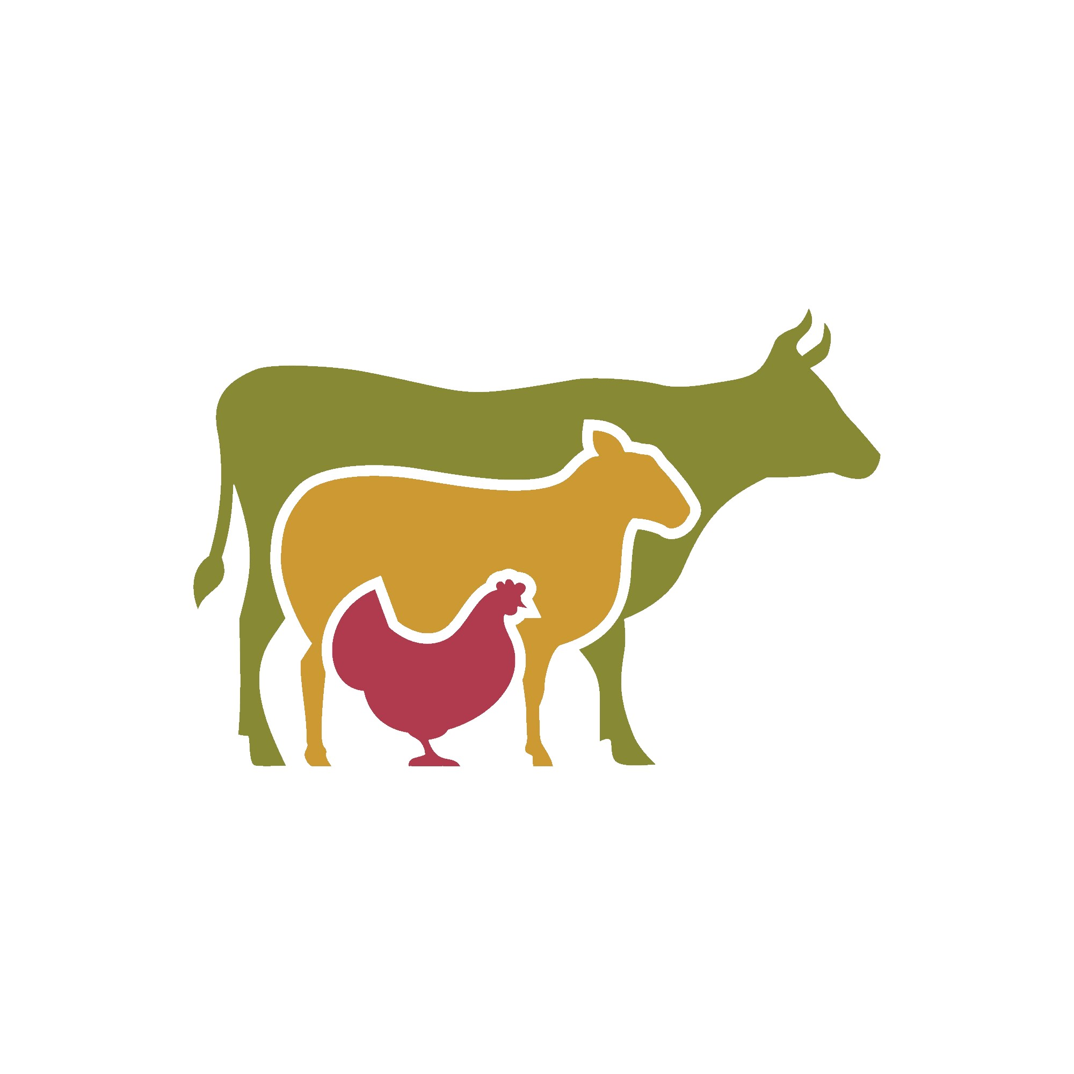

The Nuffield Council on Bioethics is an independent body that informs policy and public debate about the ethical questions raised by biological and medical research.

We are currently conducting an inquiry into the use of genome editing in farmed animals and are seeking evidence to help inform our work. We would like to hear a range of views in the following areas:

- Current research
- Socioeconomic context
- Ethics
- Law, regulation, and policy

‘Genome editing’ describes an emerging family of biological techniques for making precise, targeted genetic alterations to living cells. Genome editing applications could produce animals that are resistant to disease, have higher proportions of muscle mass, are better adapted to environmental conditions or can serve as surrogates to enable the births of greater numbers of productive offspring. The genome editing techniques and some of their potential applications are described briefly in this document.

1. Background

What do we mean by ‘genome editing’?
Genome editing is the deliberate, targeted alteration of a DNA molecule in a living cell. A large and growing family of techniques, developed over the last 15 years, can achieve this with precision and reliability. They include Zinc Finger Nucleases, TALENs and RNA- (CRISPR-) guided endonucleases, such as CRISPR-Cas9. A common approach uses a protein to cut the DNA molecule at the target site and then utilises repair mechanisms that exist naturally within every cell to re-join the severed ends. Other approaches target sequences without causing a break in the DNA molecule, either to substitute individual bases (units of the molecular code) or to modify how sections of DNA are expressed. These different approaches, which are still evolving, offer ways either to disrupt the biological function of a known DNA sequence or to create a new function by inserting an extra sequence.
Among genome editing technologies, the CRISPR-based methods that have emerged over the last few years are particularly promising owing to their relative efficiency, low cost and ease of use. They also make it possible to edit multiple places in the genome in a single procedure. This has led to their rapid uptake across a range of areas of biological research. Many people believe these techniques have the potential to give rise to new technologies that could transform animal farming. The CRISPR family of techniques has been subject to a number of refinements and research continues to discover new approaches and new applications. By ‘genome editing’, therefore, we do not mean to refer to a particular technique but, rather, to the idea of using molecular approaches to directly and intentionally alter genome sequences or gene expression.

Why is genome editing relevant to farmed animals?
Animals have been domesticated by humans for meat, dairy products, clothing and as service animals for around 11,000 years. Over long periods of time, selective breeding has led to the development of animals with features that have benefitted humans, such as increased muscle mass, fast growth rate, high fertility, docility and resistance to disease. These features also have implications for the welfare of the animals themselves, which may be positive or negative. As most of these features are genetically conditioned, this selective procedure has implicitly involved alterations to the animals’ characteristic genomes.
With the advent of genetic testing and genome sequencing it has become possible to understand the relationship between some specific genetic variants and observable features. This knowledge could be used, first, to select animals with desirable genetic traits and, then to use genetic techniques to introduce new traits that either do not exist in the breed or could not be achieved easily through traditional breeding. This second kind of molecular intervention is an area of current research that still faces considerable uncertainties. Genome editing techniques, nevertheless, potentially offer a way to develop or accelerate the breeding of animals with agriculturally desirable characteristics and to exercise precise control over this at the molecular level.
Research is currently underway using genome editing to develop new features in a wide range of farmed animals including pigs, sheep, cattle and chickens. These applications include ones that could produce animals that are resistant to disease, that have higher proportions of muscle mass, are better adapted to environmental conditions, or can serve as surrogates to enable the births of greater numbers of productive offspring. Genome editing could also be used to produce ‘bioreactors’ – animals that produce pharmaceutical and other industrially valuable products.
Future genome editing technologies could help to increase food production sustainably in order to feed the growing world population, produce drugs that are otherwise difficult to source, or improve animal welfare. However, genome editing does not offer the only or a complete response to the challenges faced, and it could give rise to new concerns. These include concerns about product safety, consumer choice, and impacts on farmed animals, the environment and people (including the climate impacts of intensive meat and dairy farming).

2. Questions

Current research
We are interested in finding out more about what is happening currently in research contexts. We would like to know what genome editing technologies in farmed animals are currently being developed and how this field is likely to progress in the future. We are also interested in hearing about what technical advantages genome editing, as compared with alternative agricultural technologies, might have in the field. These include traditional breeding but also other methods of molecular DNA alteration (e.g. transgenic modification). We would also like to hear about research projects that are currently planned or in progress, what their objectives are, and what factors are driving or limiting these projects.
- What current or planned projects of research into the use of genome editing in farmed animals do you think we ought to take into account in our inquiry?
- What kinds of innovation does genome editing make possible (or practical) that selective breeding or transgenic modification techniques do not?
- Are there biological reasons why particular (kinds of) applications in farmed animals are more or less likely to be developed and used than others?
- Are there any technical constraints or bottlenecks holding up genome editing research in this field?
- What are the expected timescales within which we might expect to see particular genome editing applications being used on farms?

The socioeconomic context
We are interested in finding out more about the context in which genome editing technologies in farmed animals are being developed, the societal challenges genome technologies might be used to address, and the different factors that might shape the trajectory of research and innovation in this area. The next few questions relate to the socioeconomic context of research, innovation and diffusion of emerging biotechnologies like genome editing.
- What are the societal, production, environmental and policy challenges to which genome editing applications in farmed animals might offer a response?
- How might genome editing technologies help to address these challenges, and what practical benefits and drawbacks would genome editing applications have over existing or envisaged alternative approaches?
- What groups or organisations are likely to benefit most from the use of genome editing in farmed animals and what groups or organisations might be disadvantaged?
- What do you think are the broader social, economic and political drivers that will facilitate, impede or otherwise shape the development and use of genome editing applications in farmed animals, and what effect do you think these will have?
- How might differing regional social, economic and political drivers influence the likely development and adoption of genome editing applications in the UK, the EU and the rest of the world?
- What effect do you think public attitudes will have on innovation in this field (in the UK, the EU and internationally) and how should researchers and policy makers take account of these?

Ethics
The next few questions invite your views on the ethical considerations relating to the use of genome editing applications in farmed animals, which are central to our inquiry. We would like to hear views on the significance of directly intervening, in different ways, in animal genomes, the potential impacts of genome editing technologies on animal welfare, the environment and human health, and the conditions under which genome editing might be permissible. In considering the ethics of genome editing interventions we recognise that current farming practices are not ethically neutral and engage often strong moral responses. While acknowledging this, we want, however, so far as possible to maintain a focus on the distinctive significance of genome editing in order to consider what impact it might have on the given state of affairs. We want to maintain this focus while acknowledging that farming practices both respond to and influence a much broader range of behaviours, preferences and conditions, which may themselves involve moral choices but are beyond the scope of this inquiry to affect.
- Are there any categorical ethical objections to genome editing farmed animals and if so on what grounds are they based?
- What, if any, are the ethical differences between using genome editing and deliberately altering an animal’s physiology in other ways, for example, by using hormones, surgical procedures or drugs?
- What, if any, are the ethical differences between using genome editing and using alternative methods such as traditional selective breeding methods, or marker assisted selection to alter the characteristics of a breed of farmed animals?
- What, if any, are the ethical differences between using genome editing, which relies on the cell’s own repair mechanisms, and using genetic modification techniques that insert transgenes into organisms?
- Are some but not other applications of genome editing in farmed animals acceptable and, if so, on what does their acceptability depend (for example, improving animal welfare, meeting objectives of importance for animals or humans, etc.)?

Law, regulation and policy
The final set of questions seeks views about appropriate regulation and policy for genome editing applications in farmed animals. We recognise that much policy and regulation in this area is connected with international trade conditions and that, for the UK especially, there is some uncertainty regarding the future of these arrangements. We are also interested, however, in the conditions for and implications of global knowledge and technology transfer. This is potentially an area where values and visions can influence decisions that will contribute to bringing about more desirable states of affairs or to averting less desirable ones.
- Are there reasons to think that genome editing approaches are inherently more likely than alternative approaches to result in adverse outcomes, or to result in outcomes that are potentially more harmful; what are the major risks or uncertainties that regulation should seek to manage?
- What are the roles of policy and markets in shaping livestock farming practices and what should be the key policy objectives in this area?
- Do you think that the existing EU regulatory framework for the production and sale of GMOs is appropriate for genome editing applications in farmed animals and, if not, what alternatives might be considered?
- How might national or regional differences in policy or regulation influence the development and diffusion of genome editing applications in farmed animals internationally?

Finally
This inquiry is gathering evidence in a number of ways, including by literature research, a number of fact-finding meetings with experts and further engagement with interested groups and organisations, and members of the public.
- Is there any important question that you think we should have asked or an area that we ought to have covered, or any other information that you would like to bring to our attention in order to help us with this inquiry?

Please do not forget to include a completed response form with your submission

3. Responding

How should you respond?
We would prefer it if you would send your response to us electronically. Responses can be sent via email to animals@nuffieldbioethics.org with Call for evidence in the subject line. Please ensure that you also include a completed response form with your submission. The response form can be found at the end of this document or may be downloaded from www.nuffieldbioethics.org/project/genome-editing-farmed-animals
If you would prefer to respond by post, please send your submission to:
Call for Evidence (farmed animals)
Nuffield Council on Bioethics
28 Bedford Square
London
WC1B 3JS

For information about obtaining a large print version of this call for evidence, please contact us in the following ways:
- Telephone: +44 (0)20 7681 9619
- Email: animals@nuffieldbioethics.org
- Website: www.nuffieldbioethics.org/project/genome-editing-farmed-animals

The closing date for written evidence is 20 September 2019.

Guidance on submitting written evidence

It will assist the Working Group if you would:

- include a short summary in bullet point form at the beginning of the document;
- limit your response to one single Word-formatted document, preferably of no more than 2,000 words in length, and preferably submitted by email;
- have numbered paragraphs throughout; and
- ensure that your submission is accompanied by a completed response form, which can be downloaded from www.nuffieldbioethics.org/project/genome-editing-farmed-animals
In addition:

- The working group’s final report may make public the evidence received during the project in full, or in selected quotation. Please state in the response form whether you wish your submission to be made public.
- If you wish to include private or confidential information in your submission, please discuss this with us before submitting it.
- Material that has previously been published should not form the basis of your submission.
- If you reference your own previously published work in your submission and feel that the working group would benefit from reading it in the published form, please send us electronic or hard copies of the referenced items together with your submission.
- Please contact us if wish to submit evidence but are unable to do so by the closing date.

Further information

The working group’s terms of reference are:
  - to identify and examine ethical questions relating to the impact of genome editing technologies on the production, use and welfare of animals for direct human consumption (or for the production of goods for human consumption).
  - to review relevant institutional, national and international policies and provisions, and to assess their suitability in the light of the ethical questions examined.
  - to report on these matters and to make recommendations relating to policy and practice.

Further information about the project and the members of the working group can be found on the project website: www.nuffieldbioethics.org/project/genome-editing-farmed-animals

Response form

Please complete the information below and return to animals@nuffieldbioethics.org. We will not publish your name without your express permission.
Your details
Your name:
Organisation (if applicable):
Email:
You do not have to provide an email address, but it would be helpful to be able to contact you should we have any queries about your response. Your email address will not be shared or published in the report.
About your response
Are you responding in a personally (on your own behalf) or on behalf of your organisation?
Personal Organisation
May we include your name/your organisation’s name in the list of respondents that will be published in the final report?
Yes No, I/we would prefer to be anonymous
If you have answered ‘yes’, please give your name or your organisation’s name as it should appear in print (this is the name that we will use in the list of respondents in the report):

May we quote your response in the report either in full or in selected parts and make it available on the Council's website when the report is published?
Yes, attributed to myself or my organisation
Yes, anonymously*
No
*If you select this option, please note that your response will be published in full (but excluding this form), and if you wish to be anonymous you should ensure that your name, and any other identifying information, does not appear in the main text of your response. The Nuffield Council on Bioethics cannot take responsibility for anonymising responses in which the individual or organisation is identifiable from the content of their response.
Obtaining consent to publish a response does not commit the Council to publishing it. We will also not publish any response where it appears to us that to do so might result in detriment to the Council’s reputation or render it liable to legal proceedings
Why are you interested in this call for evidence? (Tick as many as apply.)

Researcher
Biotechnology professional
Policy-maker
Farmer
Research Funder
Work for an NGO or charity
Work for the private sector
Work for government
Work for a government agency
Academic interest
Legal / regulatory interest
General interest
Other (please state):

We would like to send you a link to the report when it is published and keep you informed about activities related to this project. If you would like us to do so, please tick here:
If you would like to receive our newsletter on all the Council’s activities, please visit our website, or tick here:
We will use your data only to send you the newsletter, project updates, and for our internal reviews of our impact. We will not share your data with any third parties. You may unsubscribe from our newsletter at any time by clicking the unsubscribe link in any newsletter email or by emailing bioethics@nuffieldbioethics.org.
For more details of our principles when dealing with personal data, see our Privacy Policy at: http://nuffieldbioethics.org/legal.

Notes TALENs stands for ‘transcription activator-like effector nucleases’; CRISPR stands for ‘clustered regularly interspaced short palindromic repeats’ (Cas9 stands for ‘CRISPR associated protein 9’). These systems, and zinc finger nucleases (ZFNs), use endonucleases that operate as ‘molecular scissors’ to cut the DNA molecule at a desired point and exploit cell repair mechanisms to repair the cut using one of two pathways that are naturally present in all cells.
Refinements of the CRISPR system (e.g. so-called dCas-9) allow the modification of gene expression without cutting the DNA molecule (epigenetic modification). Base editing targets individual bases for enzymatic conversion and uses DNA mismatch repair mechanisms in the cell to exchange, for example, a C for a T or an A to a G, also without causing a Cas9-mediated double-stranded break in the DNA molecule.

