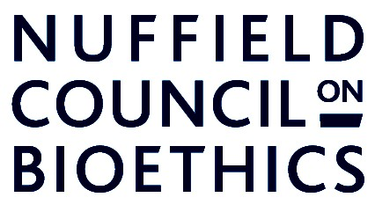

Improving asthma treatments for children and young people

Consent form for parents/guardians

Please take your time to read the information sheet and ask any questions you have before signing this consent form. Please tick all the boxes.

I have read and understand the information sheet and I have had the opportunity to ask questions.

I understand that my child does not have to take part if they do not want to and that they are free to stop taking part at any time without giving any reason.

I understand the study may involve changing my child’s asthma treatment and I have discussed these changes with my child’s doctor and understand the possible side-effects.

I agree that a gene test can be taken from my child (using a cotton swab) to find out their gene-type.

I agree that my child can take part in the online questionnaire and I am happy for their responses to be recorded and analysed for the purposes of the study.

I agree that my child can take part in lung function tests and exercise tests and I am happy for their results to be recorded and analysed for the purposed of the study.

I have talked to my child and doctor about the study.

I agree to my child taking part in the study.

Name of child…………………………………………………………………..

Name of parent/guardian……………………………………………………..

Signature………………………….………..Date……………………………..

