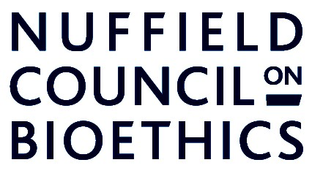

Improving asthma treatments for
children and young people

November 2013

Dear Parent/Guardian,

We are a group of medical researchers from the University of Hove, who are developing a new way of finding the best treatment for children and young people who still experience asthma symptoms despite using a ‘preventer’ (brown) inhaler and a ‘reliever’ (blue) inhaler. Where the brown and blue inhalers aren’t enough to control a child’s asthma, they will be given a ‘Stage 3 Defence’ medicine too. There are two different Stage 3 Defence medicines used in hospitals at the moment, and we are researching new ways of finding which of these two medicines will be better for any particular child.

We are writing to you because your doctor has indicated that your son/daughter experiences asthma symptoms despite taking both types of inhalers and a Stage 3 Defence. We would therefore like to invite your son/daughter to take part in this study.

The study would involve your son/daughter being prepared to try a different treatment for their asthma and we have included an information sheet and consent form with this letter so that you can find out more about the study and what it involves. Our contact details are given on the information sheet. The study has been approved by a Medical Research Ethics Committee and welcomed by your child’s doctor.

We hope you feel you can support this study and do please feel free to contact us should you have any further questions.

Yours sincerely,

Professor Somnath Mukhopadhyay

